**Lab 2**

1. Intermediate Result 1

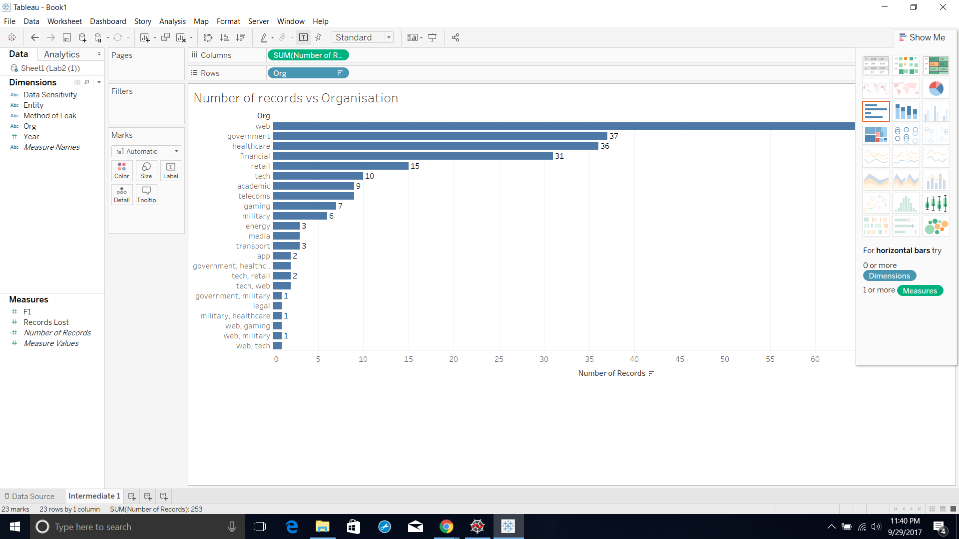

Disadvantage: This says web organization is most prone to leaking of records, but it doesn’t actually say the records lost through the organization. So we cannot actually infer which is most prone to losing records. So we need to use records stolen individually and total them instead of totaling the number of records as a whole.

1. Intermediate Result 2

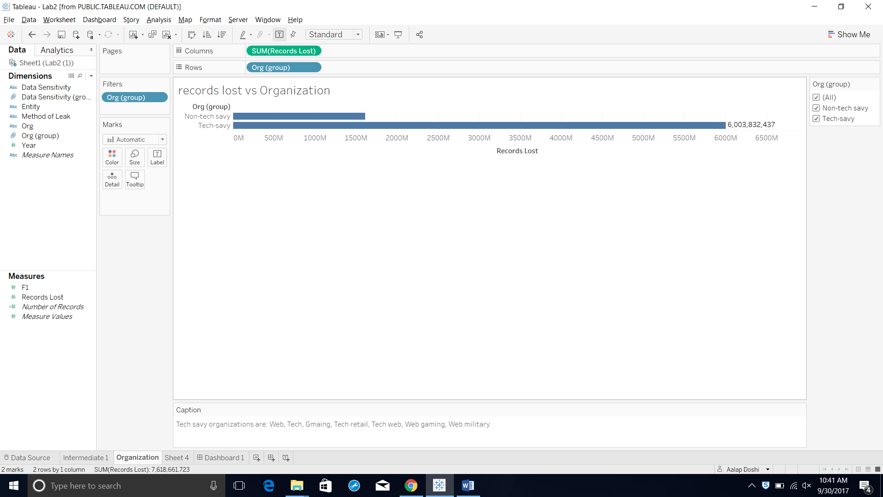

Advantage: As we can see now that clearly says tech-savy organizations such as web, gaming, tech, web-tech,etc are maximum prone to leaks or losing their records as they clearly share the huge number of records losing the data. Since we need further insights about how are tech organizations losing all the records we need to include method of leak as well.

1. Final result

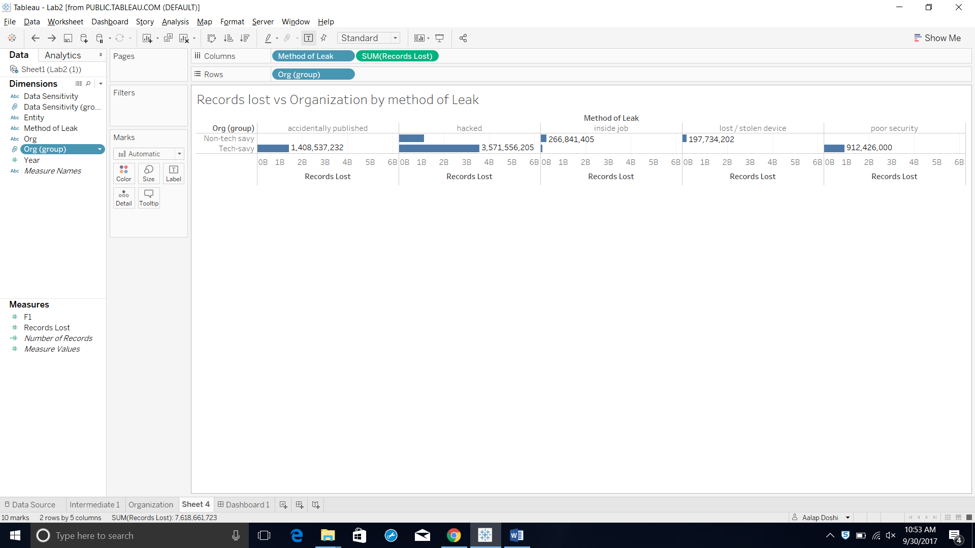

So we now add method of leak as different category and split records accordingly. As we can clearly see now with more insight that poor security breaches which is accidently published, hacked and poor security mostly occur in tech-savy(as defined above) leading to the conclusion in support that less tech-savy organization are less prone to losing their records in terms of security breaches.